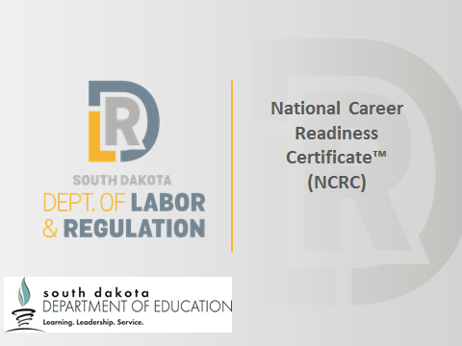 | Slide 1  Today we’re going to talk about your NCRC certificate level and scores on the individual assessments, and what you can/should do with those scores.
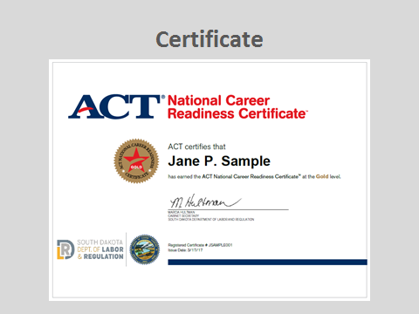 | Slide 2  You remember from the introductory PowerPoint that to earn a certificate, you had to have scored at least a 3 on each one of the three assessments.  Take a minute to look at your certificate.  On the front you’ll notice  - Your name (check spelling)  - Your level  - Your individual certificate number and date it was issued  - The Cabinet secretary’s signature  - State seal  On the back you’ll see  - Specific level of skills you can share with employers  - Directions on how to access your account
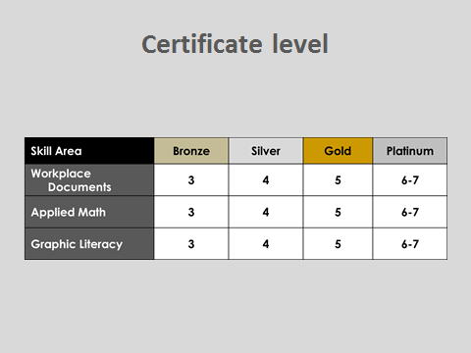 | Slide 3  Your certificate level (bronze, silver, gold, or platinum) is based on the LOWEST score you earned.  So, if someone earned scores of 7/7/5, what would their certificate level be? (gold)  If someone earned 4/5/3, what would their level be? (bronze)  People are often disappointed their certificate level isn’t an average of their three scores, but a high score in math doesn’t compensate for a lower score in reading. That’s why it’s very important you are able to talk about your individual scores.  Let’s practice this now. I want you to pretend you’re in a job interview with the person next to you, and share with them your INDIVIDUAL assessment levels, and some of the skills that proves you have.  For instance, I might say, “You can see I have a gold certificate, but I scored at the platinum level in both math and reading. That proves I have skills in critical thinking; and comparing, summarizing, and applying information presented graphically.”  (Give students time to practice.)  One neat thing about this is that in being able to talk about it, you’ll probably be put in the best place in that job. If math is a weakness for you but graphic literacy is a strength, you’re going to be better suited for one position than another. Having you and your employer recognize your strengths from the beginning will be better for both of you.  Now that you have your scores, what should you do with them?
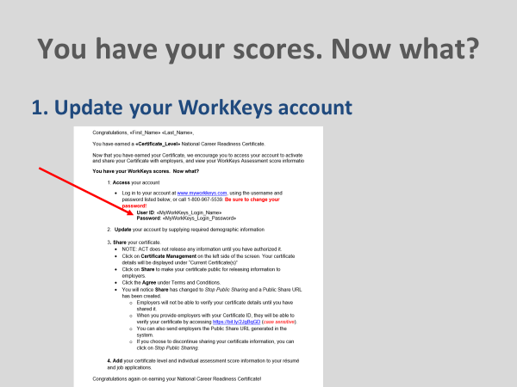 | Slide 4  The first thing you should do once you have your certificate is update your account. You will find the login information in the cover letter of your results packet.  (Note: If you can, give the students time to do this.)  - Go to MyWorkKeys.com  - Log in using User ID and Temporary Password found in the letter  - First time in will have to answer a couple of demographics questions (anything with a * is required)  - Using the navigation on the left side, click on Certificate Management  - Click Share  - Click Agree  - Click Submit  - A link will appear, which is what you will use to give to a potential employer or to add to your résumé  Sharing it doesn’t mean everyone will be able to access the information. The only people who will be able to see it are those you’ve given the link to.
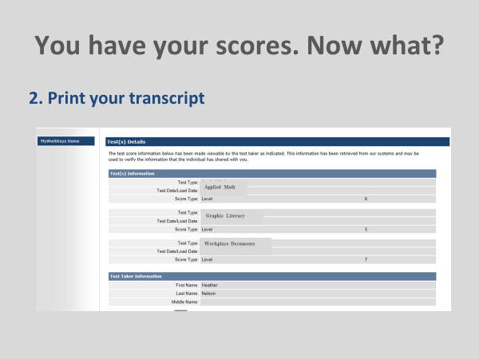 | Slide 5  You see in your packet you have a summary report for the assessments. This report will match the transcript you can print free from your account as often as you want.  (Note: Again, if you have time, have the students print a transcript)  Go to MyWorkKeys.com  Log in using User ID and Temporary Password found on cover letter  If it’s their first time in, they will have to answer a couple of demographics questions (anything with a * is required)  Click Test Management on the left-hand side of the screen  Click Share beside each assessment  Click on the URL that appears above the assessments  Print  Let’s see how you can use your individual scores to explore different occupations.
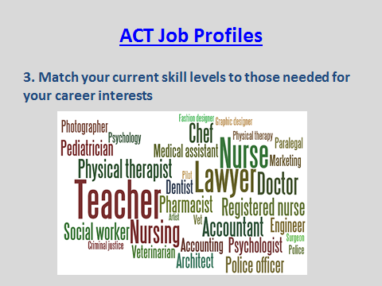 | Slide 6  You might remember from the introductory PowerPoint that ACT has studied and profiled over 20,000 jobs.  They worked with people who are actually performing the jobs to determine what skills they are using, and at what level they are using them.  Then they assigned the WorkKeys skill level (bronze, silver, gold, or platinum) to each.  Let’s spend some time exploring the site where ACT has collected all of this information.  (*Note: Both the heading and the picture are linked to the Job Profiles site. The link is http://profiles.keytrain.com/)  *Note: due to the name change, the current assessment titles might be listed as Locating Information rather than Graphic Literacy and Reading for Information rather than Workplace Documents.  Hand out the Occupation Investigation worksheet. Complete the worksheet as it works best for you—as a class or individually.  When the students have finished:  I heard a couple of you mention your current skills aren’t what they need to be for a job you’re interested in—that is question 2a.  Let’s talk about what this might look like.
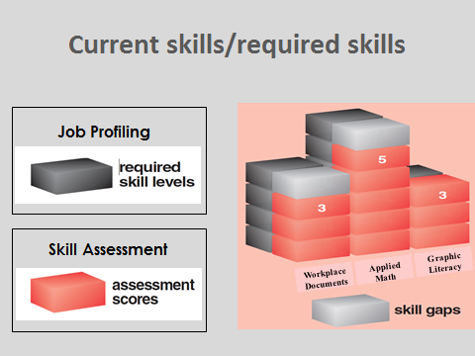 | Slide 7  Remember: most of you have scores higher than your certificate level, so you will want to emphasize the score you earned on each assessment more than your overall certificate level.  The black boxes in this graphic show a potential job suggests  Level 4 in workplace documents  Level 6 in applied math  Level 3 in graphic literacy  The red boxes show the person who took the assessments scored  Level 3 in workplace documents  Level 5 in applied math  Level 3 in graphic literacy  Does the person have the skills necessary to perform the tasks for this job?  - Yes in graphic literacy  - No in workplace documents and math—needs to move up a level in each  Now, we hope that through the rest of this school year and, as you move into the world of post-secondary or work, that gap will close.  What if it doesn’t, or what if you don’t want to wait?  One thing you can do is ask me to request a WorkKeys Curriculum account for you.  WorkKeys Curriculum is an online curriculum that matches the WorkKeys assessments. It has pre- and post-tests and lessons for each level.  The Department of Labor recommends people who use WorkKeys Curriculum work at least through the level they want to earn, if not one level higher.  That way, you can be pretty sure you should be able to earn the level you’re shooting for when you go back to test.  You can re-test in just the area you want to raise your score—you don’t have to re-test in all three.  If you raise your score and earn a higher certificate, it will automatically come to you. You don’t have to order or pay for it.  Let me know if any of you are interested in a WorkKeys Curriculum account, and I’ll get one set up for you.
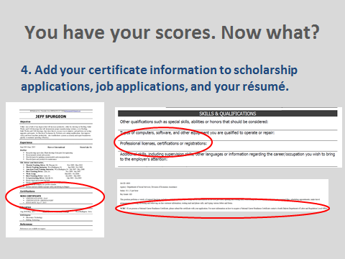 | Slide 8  The last thing I strongly recommend is that you add your NCRC information to scholarship applications, job applications, and your résumé.  It’s just like any other certificate you earn—you want to brag about it.  And even if the employer doesn’t know what it is, it still might be something that makes you stand apart from other applicants who otherwise are just as qualified as you are for the job.
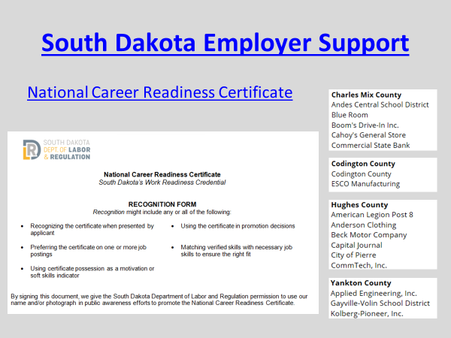 | Slide 9  Note: **Both headings will take you to the site:  http://www.dlr.sd.gov/workforce_services/ncrc/ncrc_benefits_for_employers.aspx  The Department of Labor is encouraging employers to use the NCRC as a way to get the best employee in the best position, as we talked before, so the push isn’t just on using it as a hiring tool. The Department is receiving more recognition forms from employers every week.  This slide shows you just a few of the employers who recognize the NCRC. I can take you to the site if you want to see more.  (**The list is about two thirds of the way down the page and has the heading Employer Support)
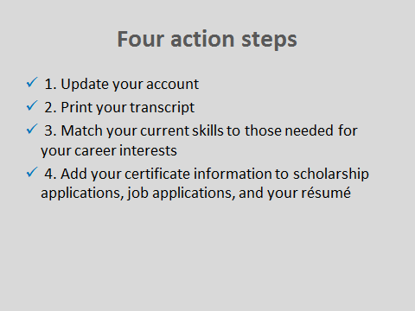 | Slide 10  Let’s review the four things you should do with your scores (go through each again).  Reflect:  - How might earning the NCRC benefit you?  - How might it benefit employers?  Any other questions or thoughts?

