NCRC Occupation Investigation

Access the ACT Occupational Database at http://profiles.keytrain.com

- Use the Job Title function to search for a job you are currently interested in pursuing, and choose the best fit from the results:

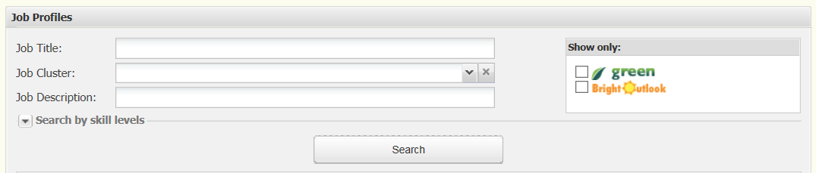

- Complete the table
 | Median skill level needed for the job | Your current skill level | Are there gaps between your skills and what you need?
Applied math |  |  | Y/N
Graphic Literacy |  |  | Y/N
Workplace Documents |  |  | Y/N

- Is the job green? Yes No

- Does the job have a bright outlook? Yes No

- Click on the blue ONET code
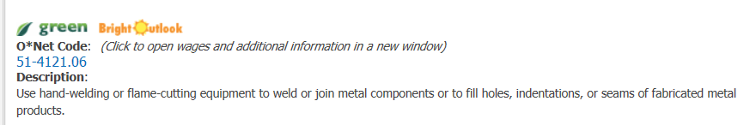
- Explore skills, abilities, education requirements, interests, wages and employment trends.

- Use the Find Jobs tab to search for jobs in South Dakota.

- Close the job window, and this time use the Job Cluster to search by a general area you might be interested in pursuing.
  - List two jobs you haven’t considered before but might take the time to explore.
    - ____________________________________
    - ____________________________________

- Clear the Job Cluster search, and use the dropdown arrow beside Search by skill levels.
  - Enter the scores you earned in each area, and list two jobs you have not previously considered that match those levels.
    - ____________________________________
    - ____________________________________

- Continue exploring!

